16London Website — Requested Changes

1. Membership / Pricing Section

Plan 1 — 16London Trend Algo
Price: $59.99/month
Includes:
- 16London Trend Algo V1
- Members Portal Access
- Full Video Course

Plan 2 — Trend Algo + London X
Price: $89.99/month
Includes:
- 16London Trend Algo V1
- London X System
- Members Portal Access
- Full Video Course
Plan 3 — 16London Complete System
Price: $119.99/month
Includes:
- 16London Trend Algo V1
- London X System
- 16London ATM System
- Members Portal Access
- Complete Video Masterclass
- Future System Updates
Please make the $119.99 Complete System the highlighted package and change the badge from “MOST POPULAR” to “BEST VALUE.”
Change its button to:
GET COMPLETE ACCESS

Remove this image and replace it with the below image
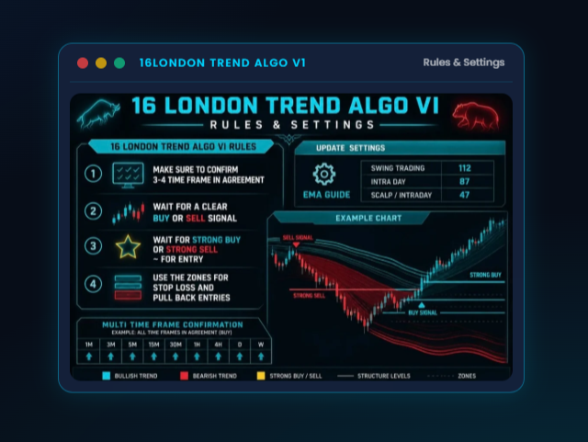



And for the this image remove it and add the other

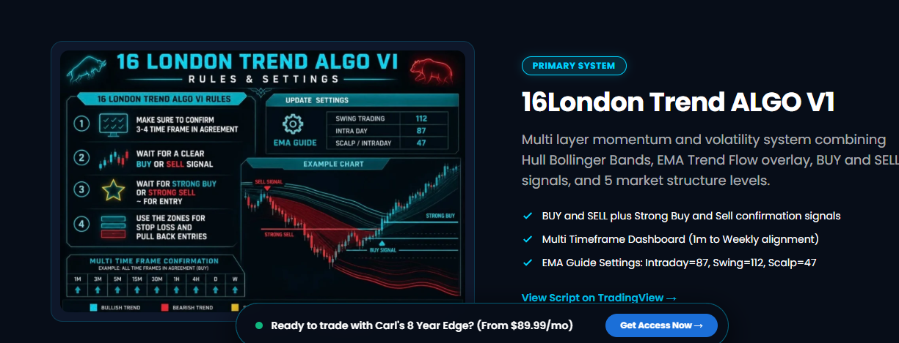

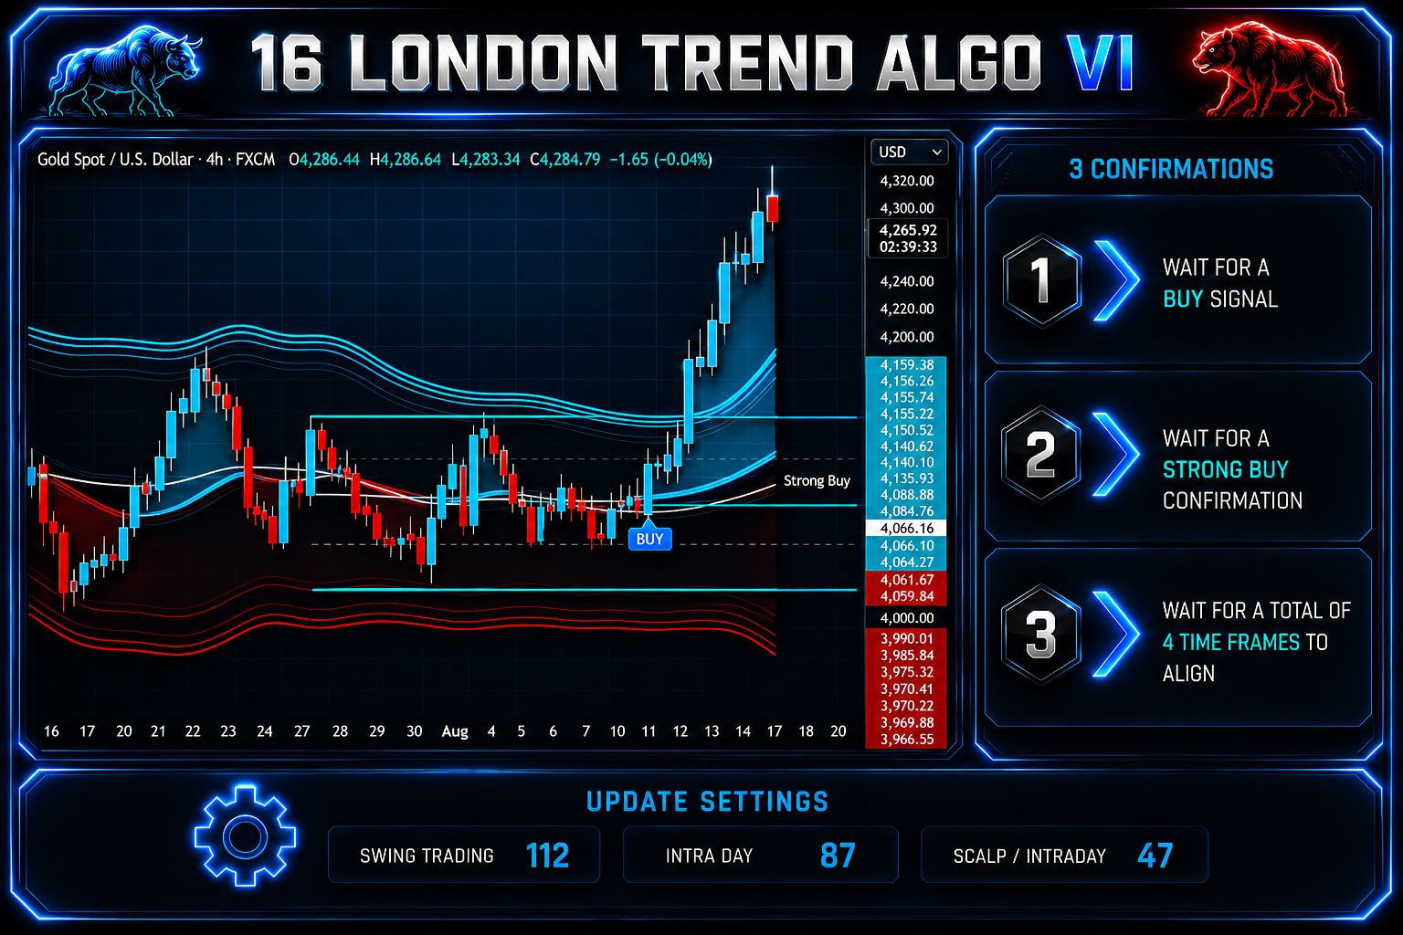

Remove this image and replace it with the below image
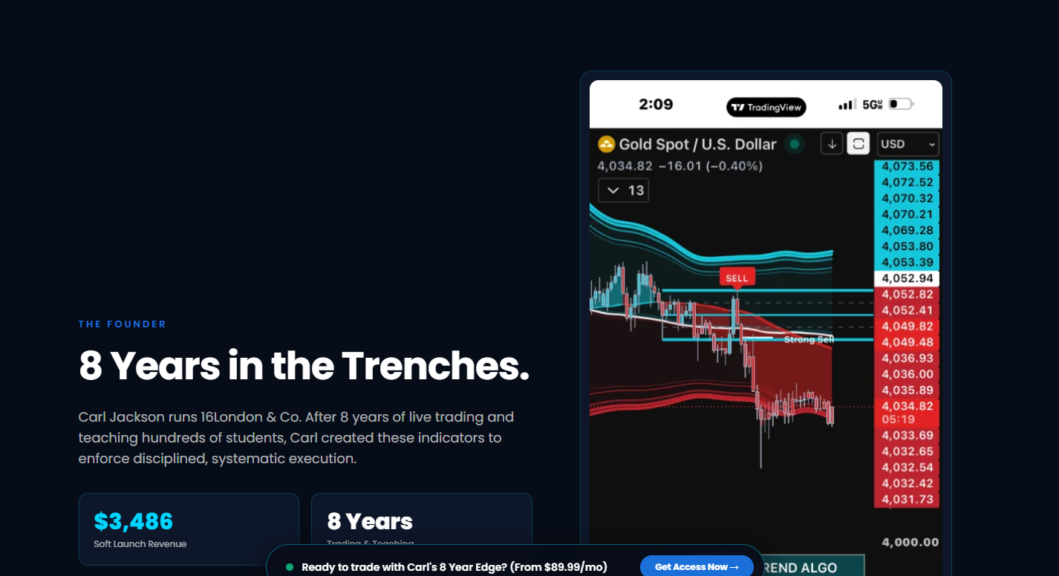

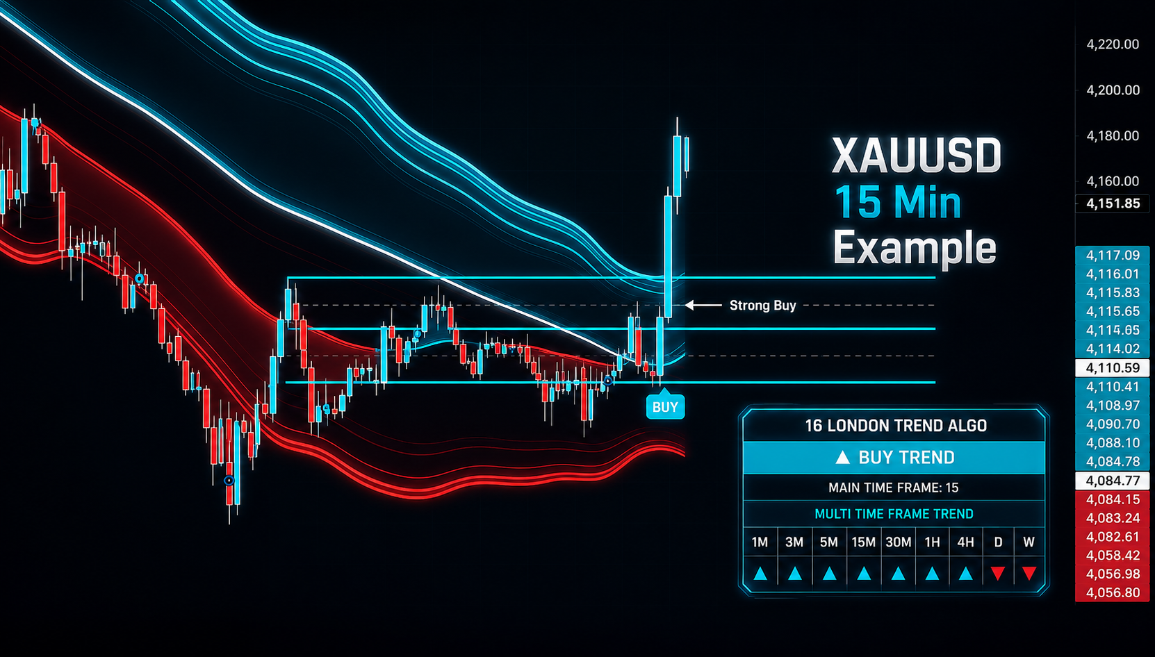

Please also change the Name from Carl to Kazi every in the website

Please add my Free Telagram Group same as
Via Free Group Link https://t.me/+QJ-dznDcXGFmODJh

You can leave the Trading view but add the free telegram and
Follow us on TIKTOK
At Link www.tiktok.com/@16londonalgo

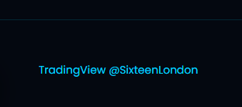

And for the members who paid to have the course access
They can join the Group via 16London Course Link https://t.me/+_JqY7DXwWpAxOGUx

